23ba1a050y
Gayathri Bellamkonda
Experiment – 2 Analyzing Android App Permissions and Mobile Traffic

Open Android Studio -> Open device manager -> select any device
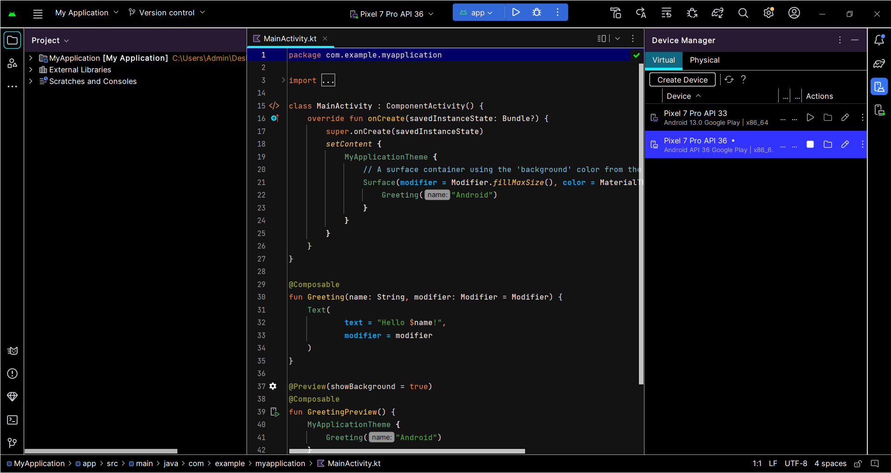
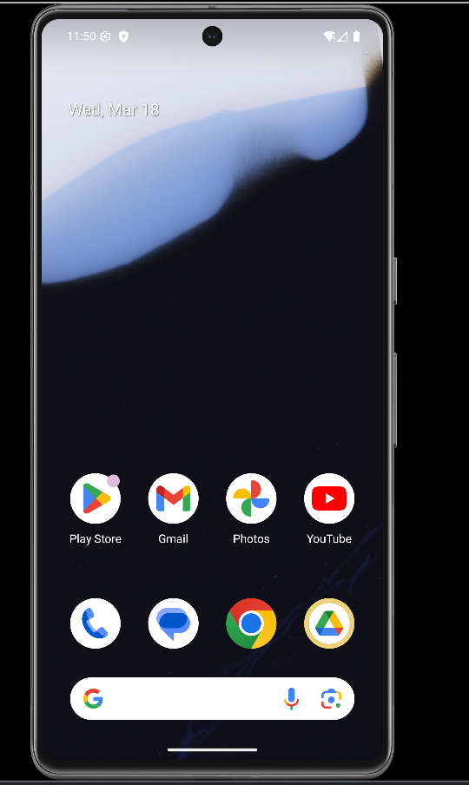
Settings-> Network and Internet-> wifi ->select icon -> top right corner there is edit->advanced options -> proxy->Change proxy None->Manual->Hostname as 10.0.2.2 ->save
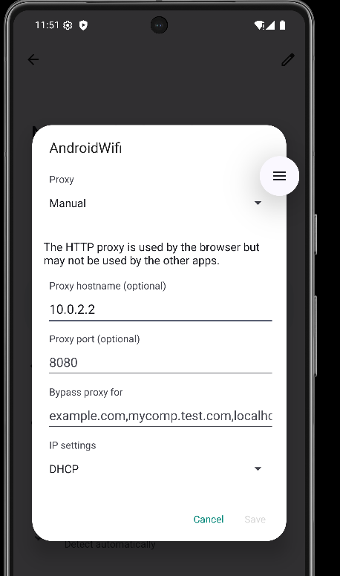
Note:if save option is not working then follow the steps in command prompt

Open ommand Prompt :
C:\Users\Admin>cd C:\Users\Admin\AppData\Local\Android\Sdk\platform-tools
C:\Users\Admin\AppData\Local\Android\Sdk\platform-tools>adb devices
C:\Users\Admin\AppData\Local\Android\Sdk\platform-tools>adb shell settings put global http_proxy 10.0.2.2:8080
C:\Users\Admin\AppData\Local\Android\Sdk\platform-tools>adb shell settings get global http_proxy

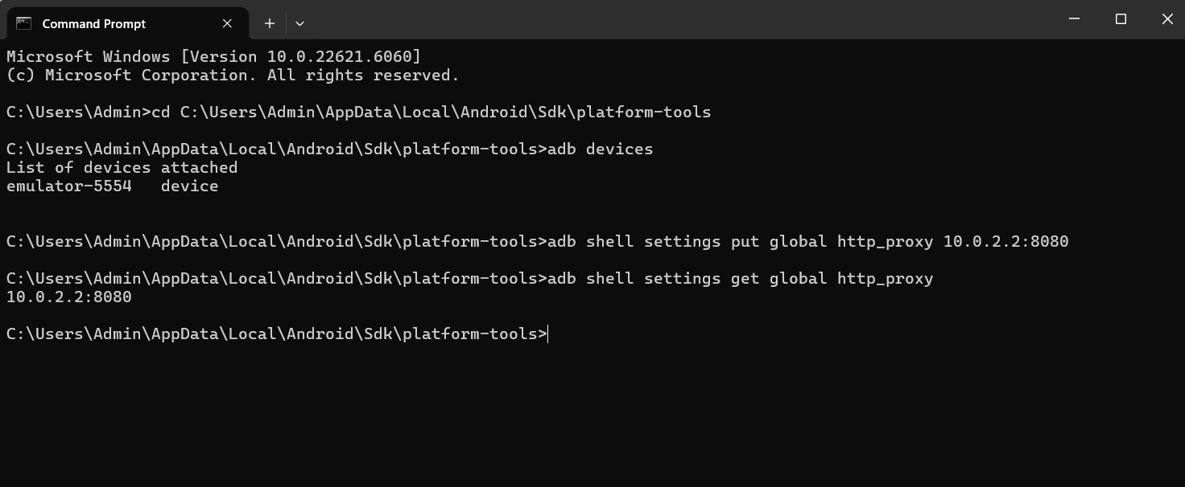

Go proxy->options/proxy settings->under Proxy Listeners->Edit->select All interfaces->ok
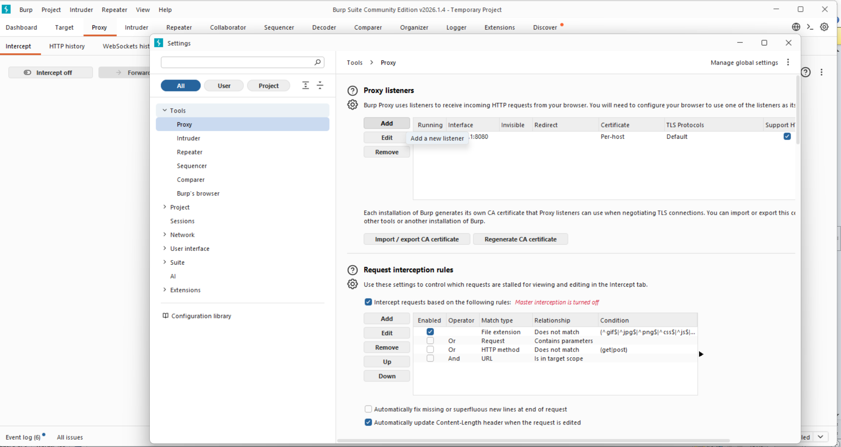

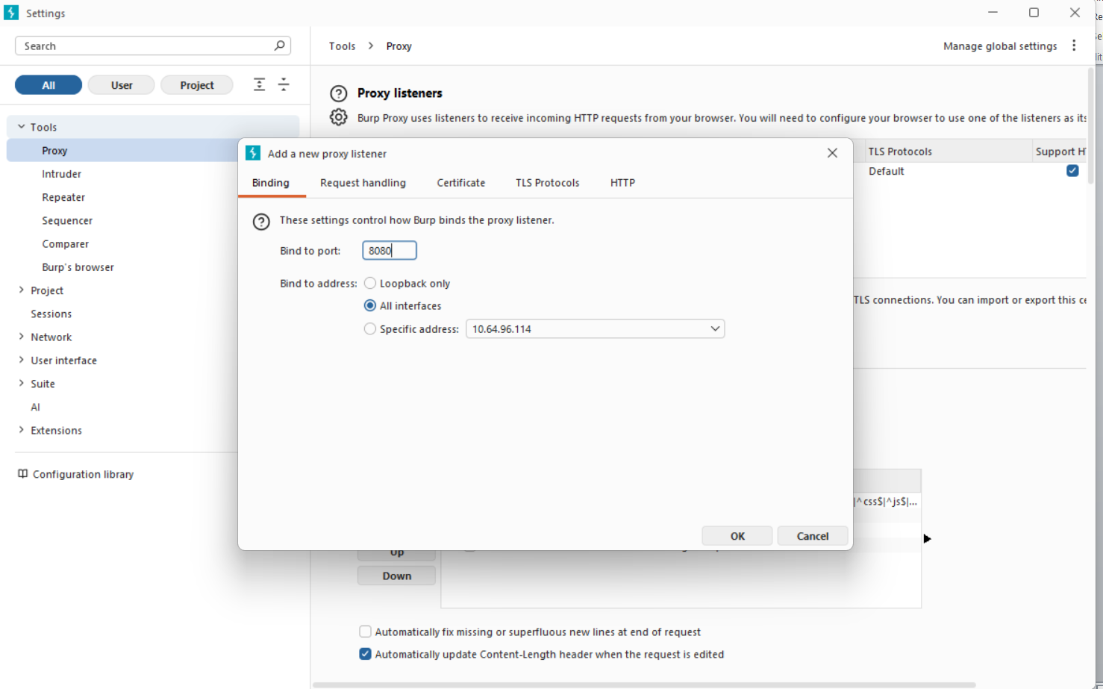
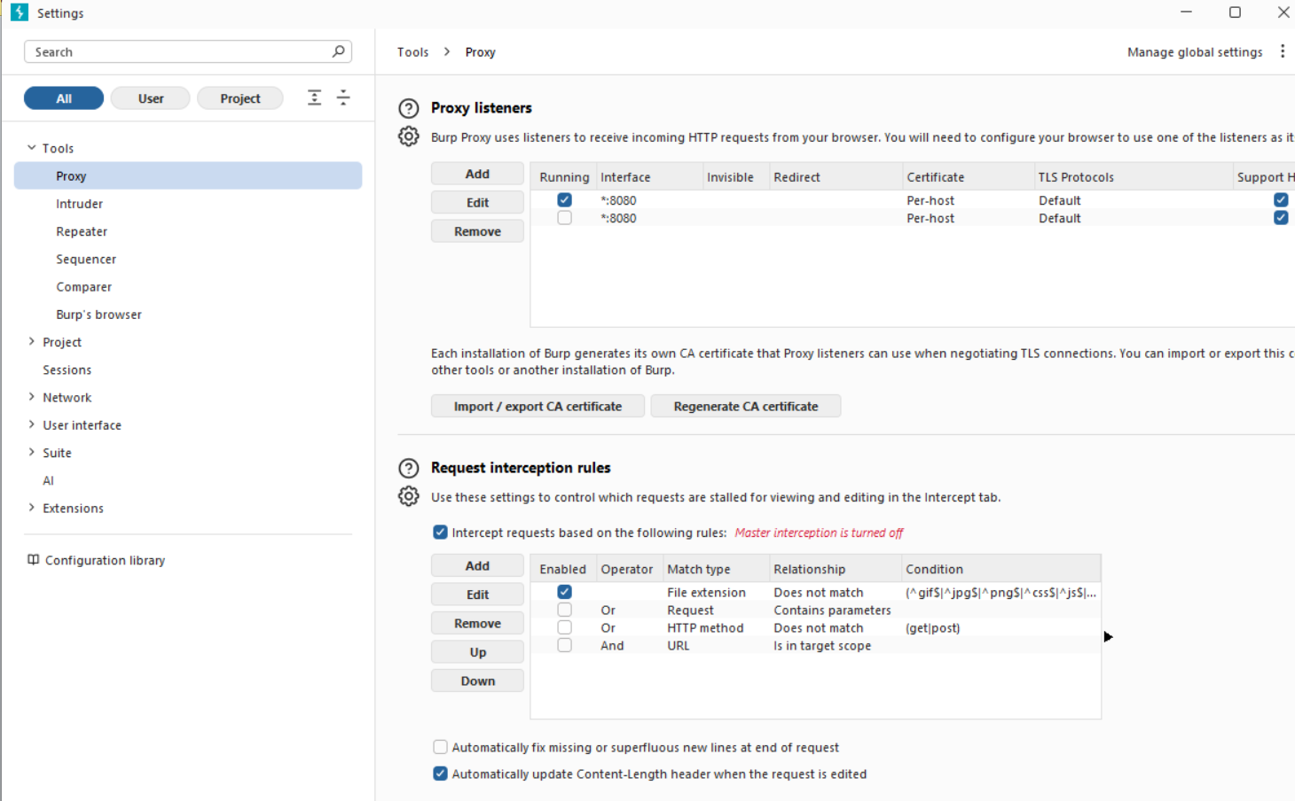
In AVD type in chrome example.com and you can see burpsuit HTTP history
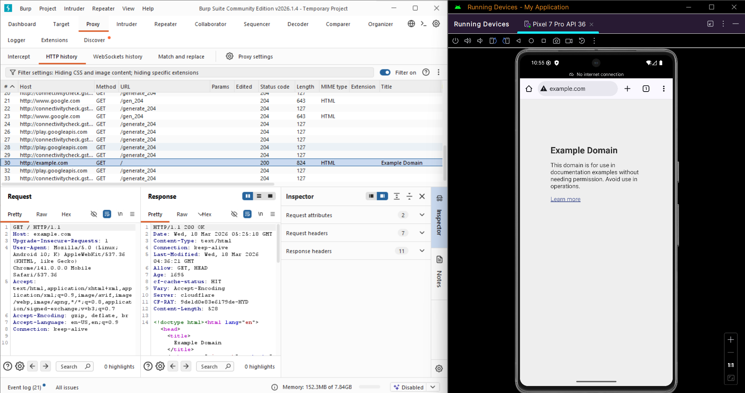

Go procy->options/proxy settings->import/export CA certificate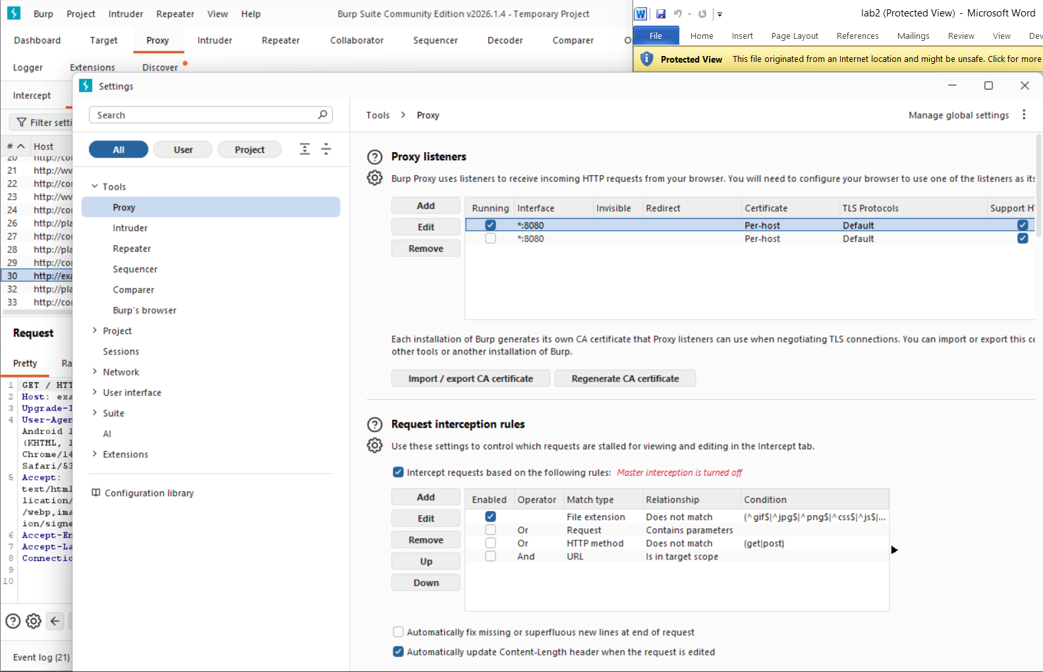

Certificate in DER format->select file-> Downloads->give name as burpcer.der
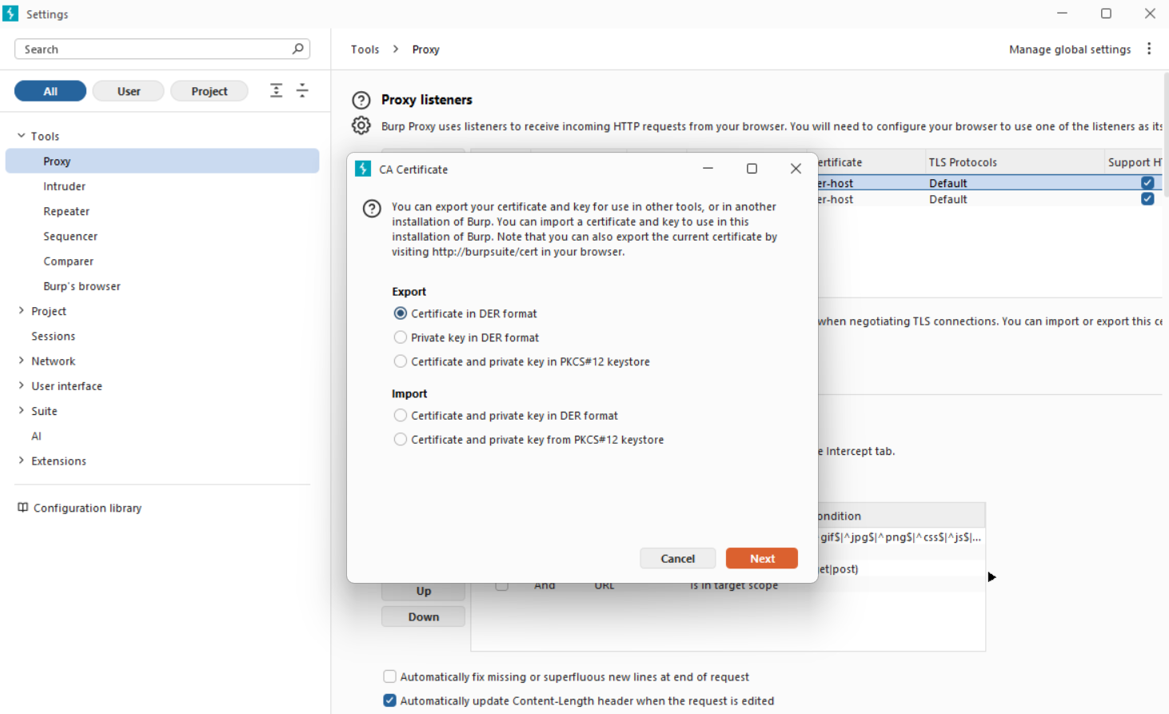
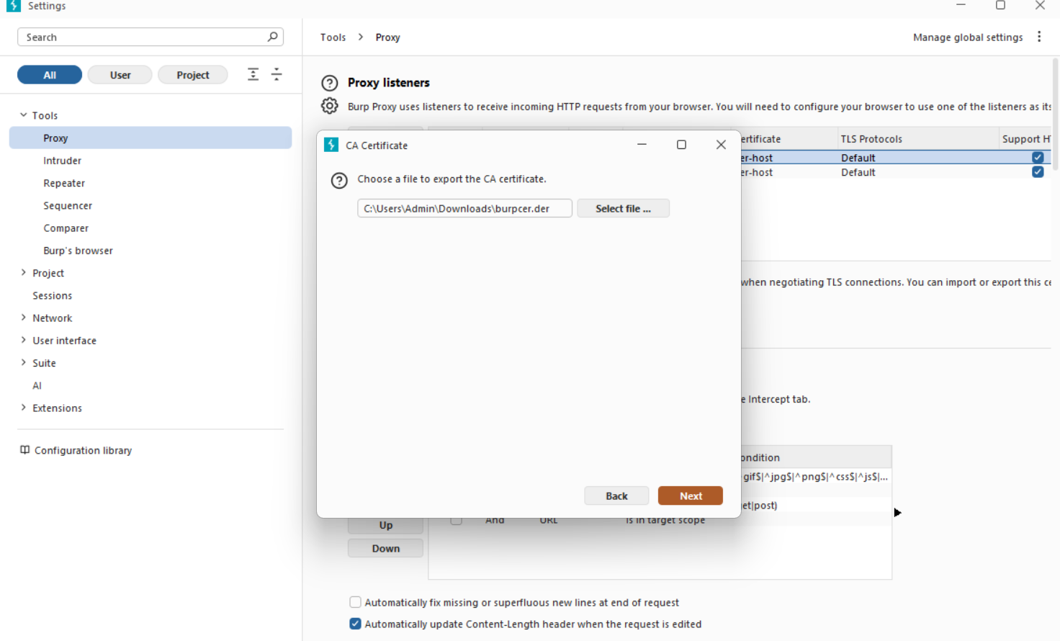

C:\Users\Admin\AppData\Local\Android\Sdk\platform-tools>adb push C:\Users\Admin\Downloads\burpcer.der /sdcard/Download/burpcer.der
Settings
→ Security & privacy
→ More security & privacy
→ Encryption & credentials

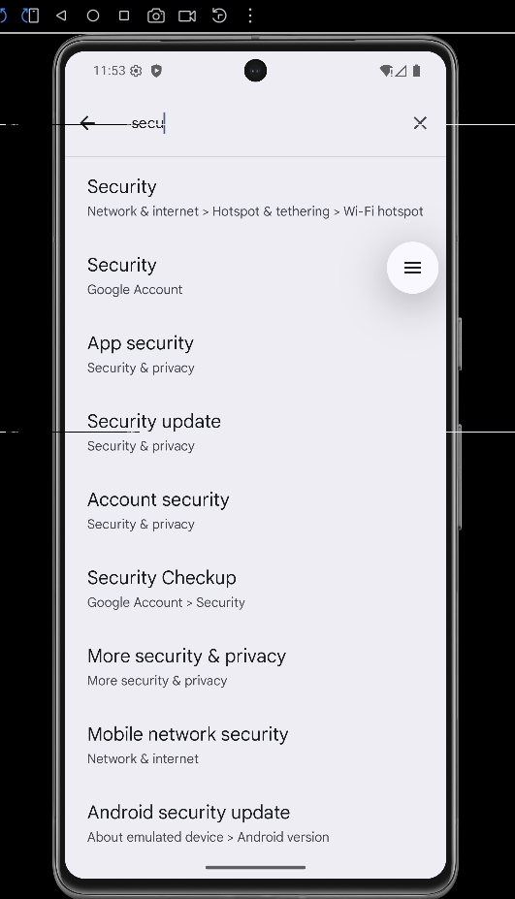

→ Install a certificate
→ CA certificate
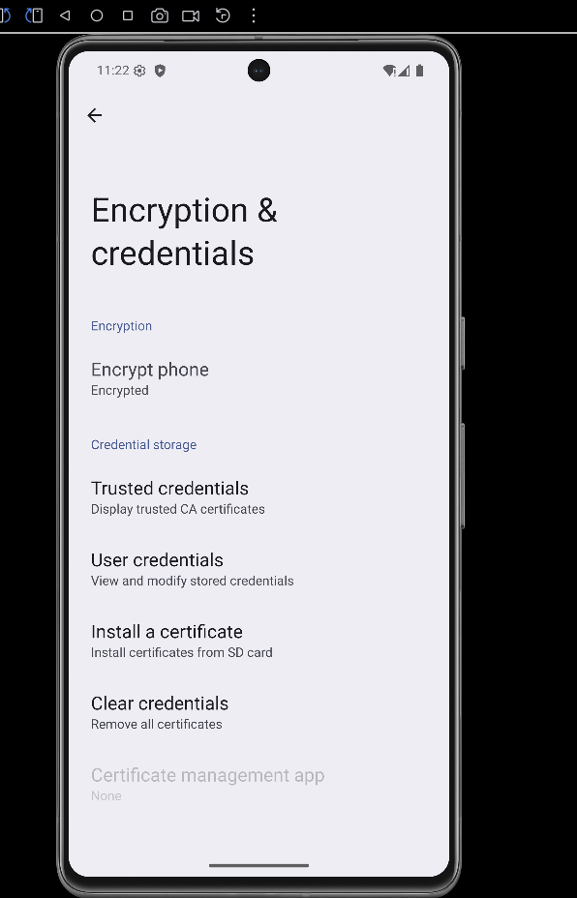
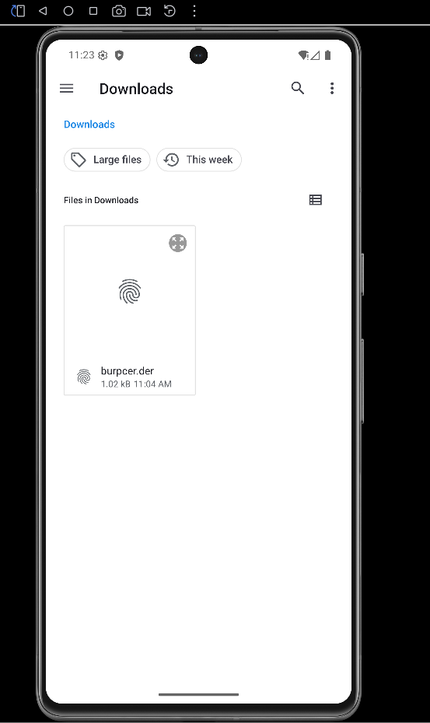

Open browser in emulator.
Visit any HTTPS website.
Example:
https://example.com
In Burp Suite, check Proxy → HTTP History.
